Computer Graphics – Final Project Report

Yuxiao Zhang

1. Introduction

The Final Project is a game called Maze. In this game, you are an adventurer and are seeking for “The Magic Fountain”. That’s why you are here in a maze at midnight. The player should find a way to the fountain in this not-so-simple maze. The key to the victory is to first find the way to some buildings called lighthouse, a very tall building with spots light on the top of it. The player can climb on it and learn the path of the maze with a bird’s view.

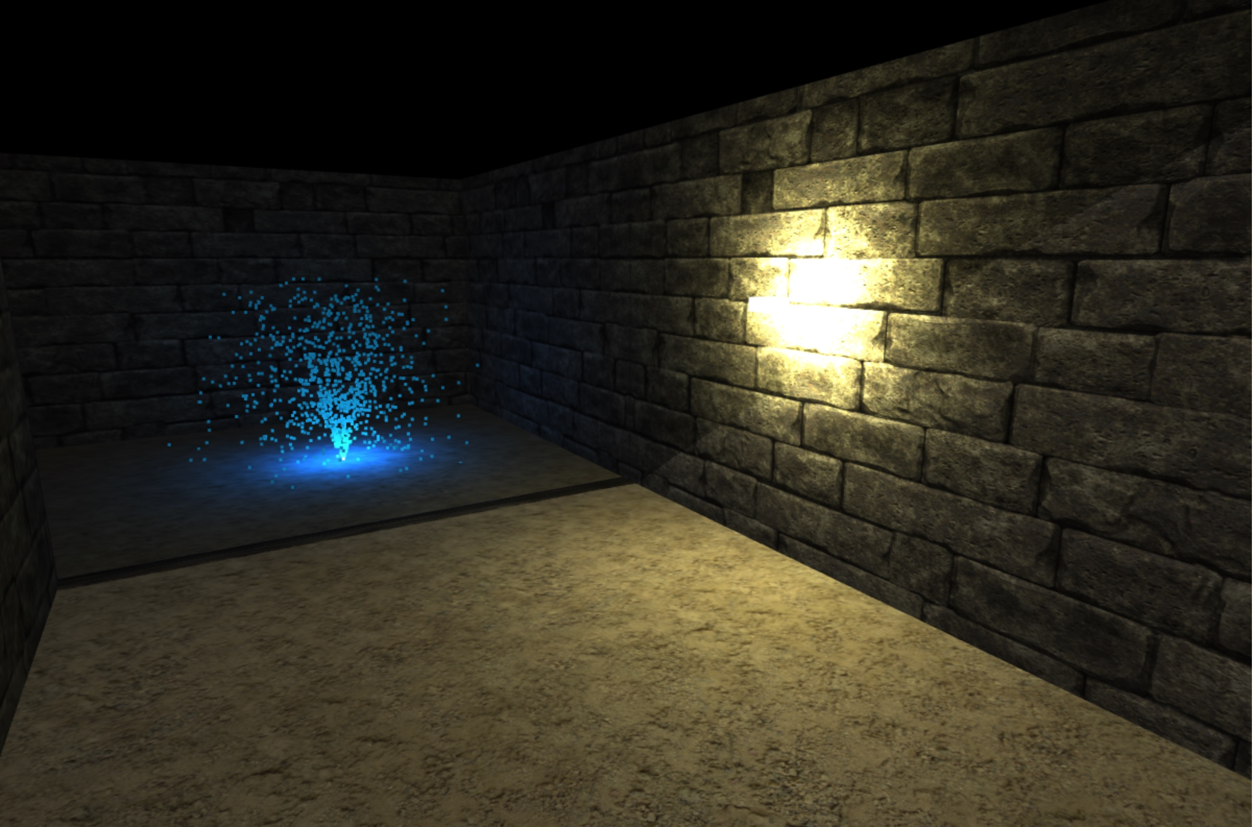

Figure 1: Wall lamp and Magic Fountain

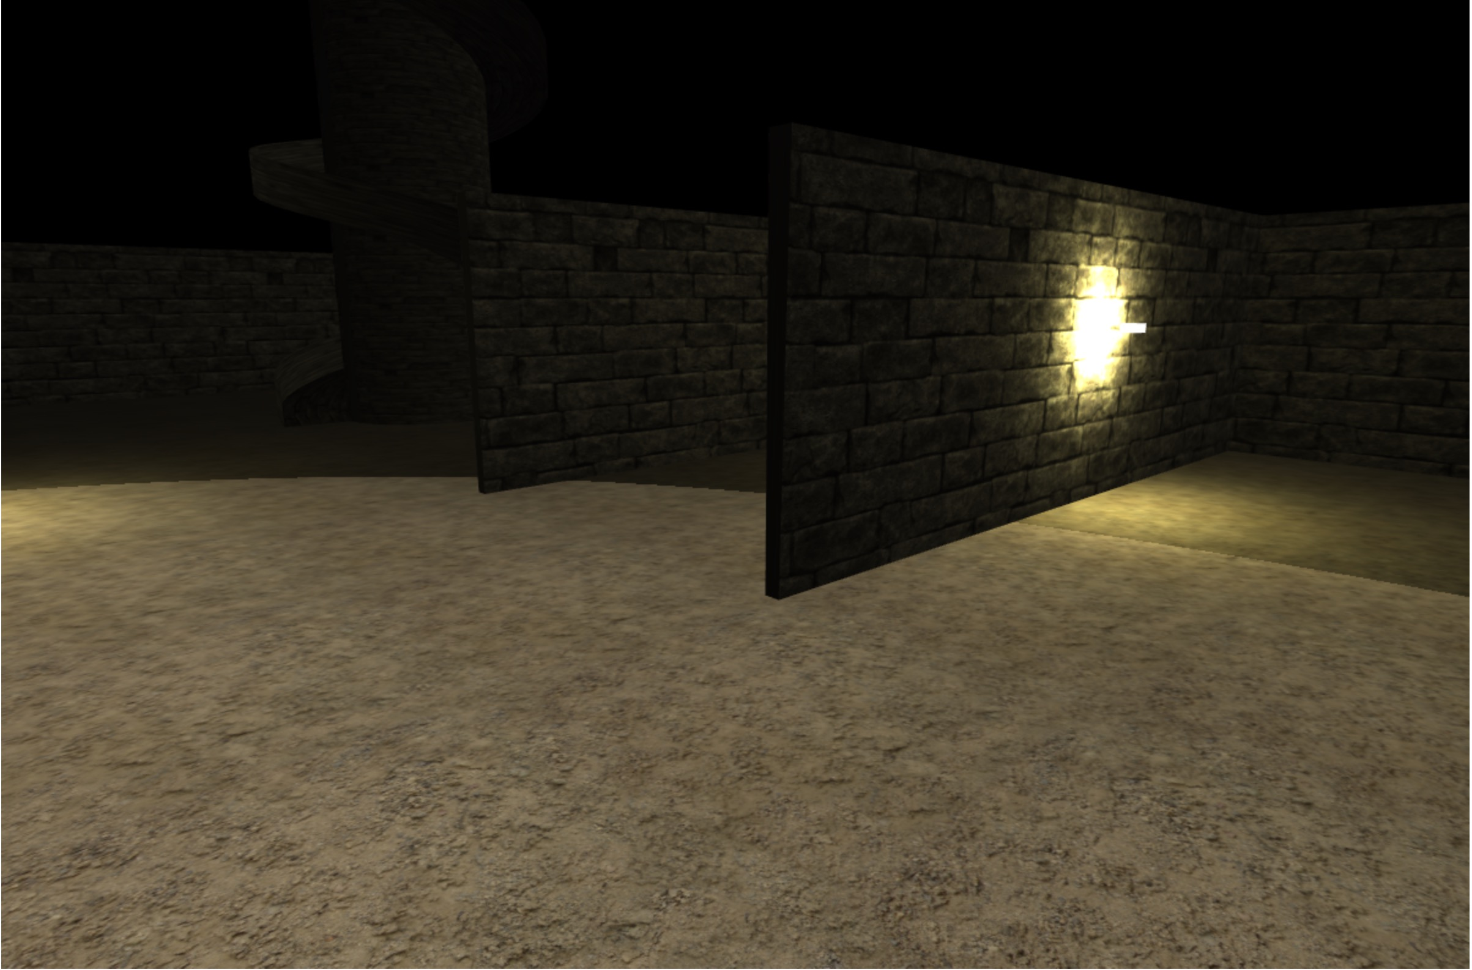

Figure 2. Walls and Powerful spotlight

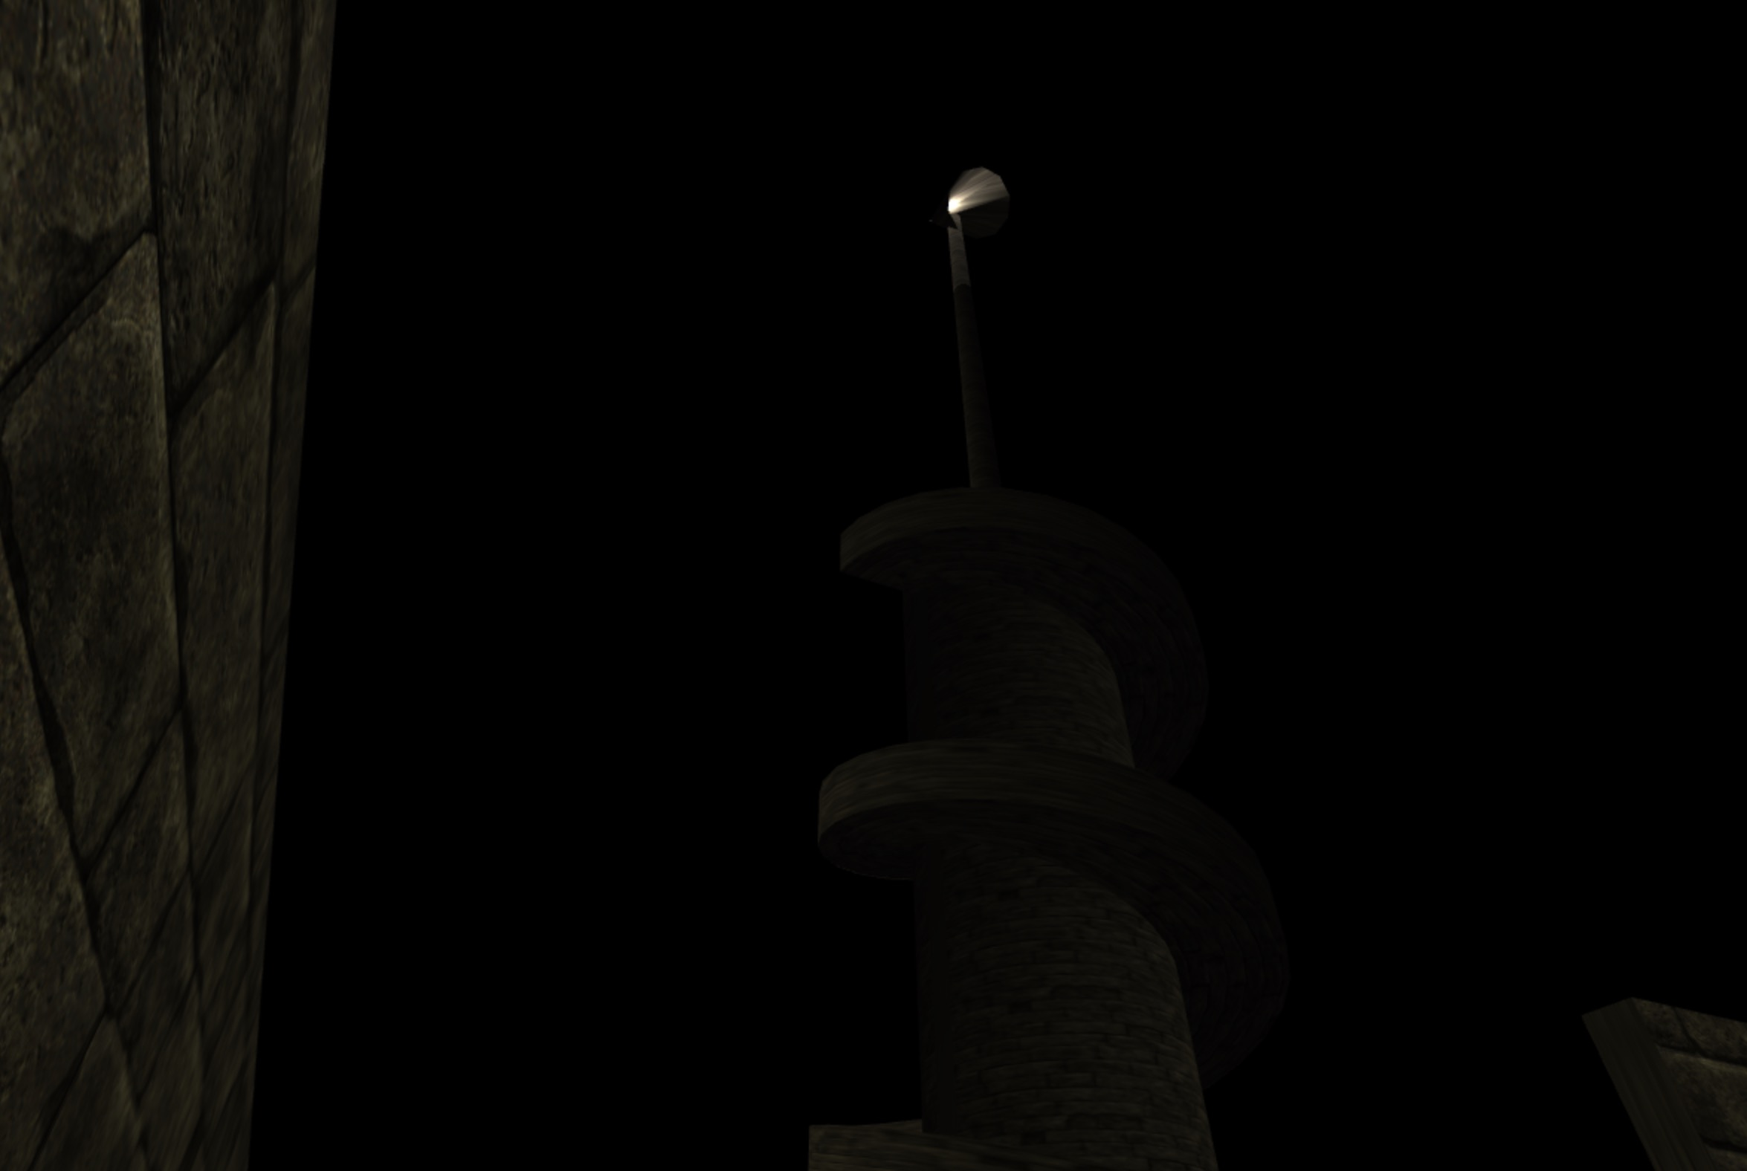

Figure 3. A lighthouse

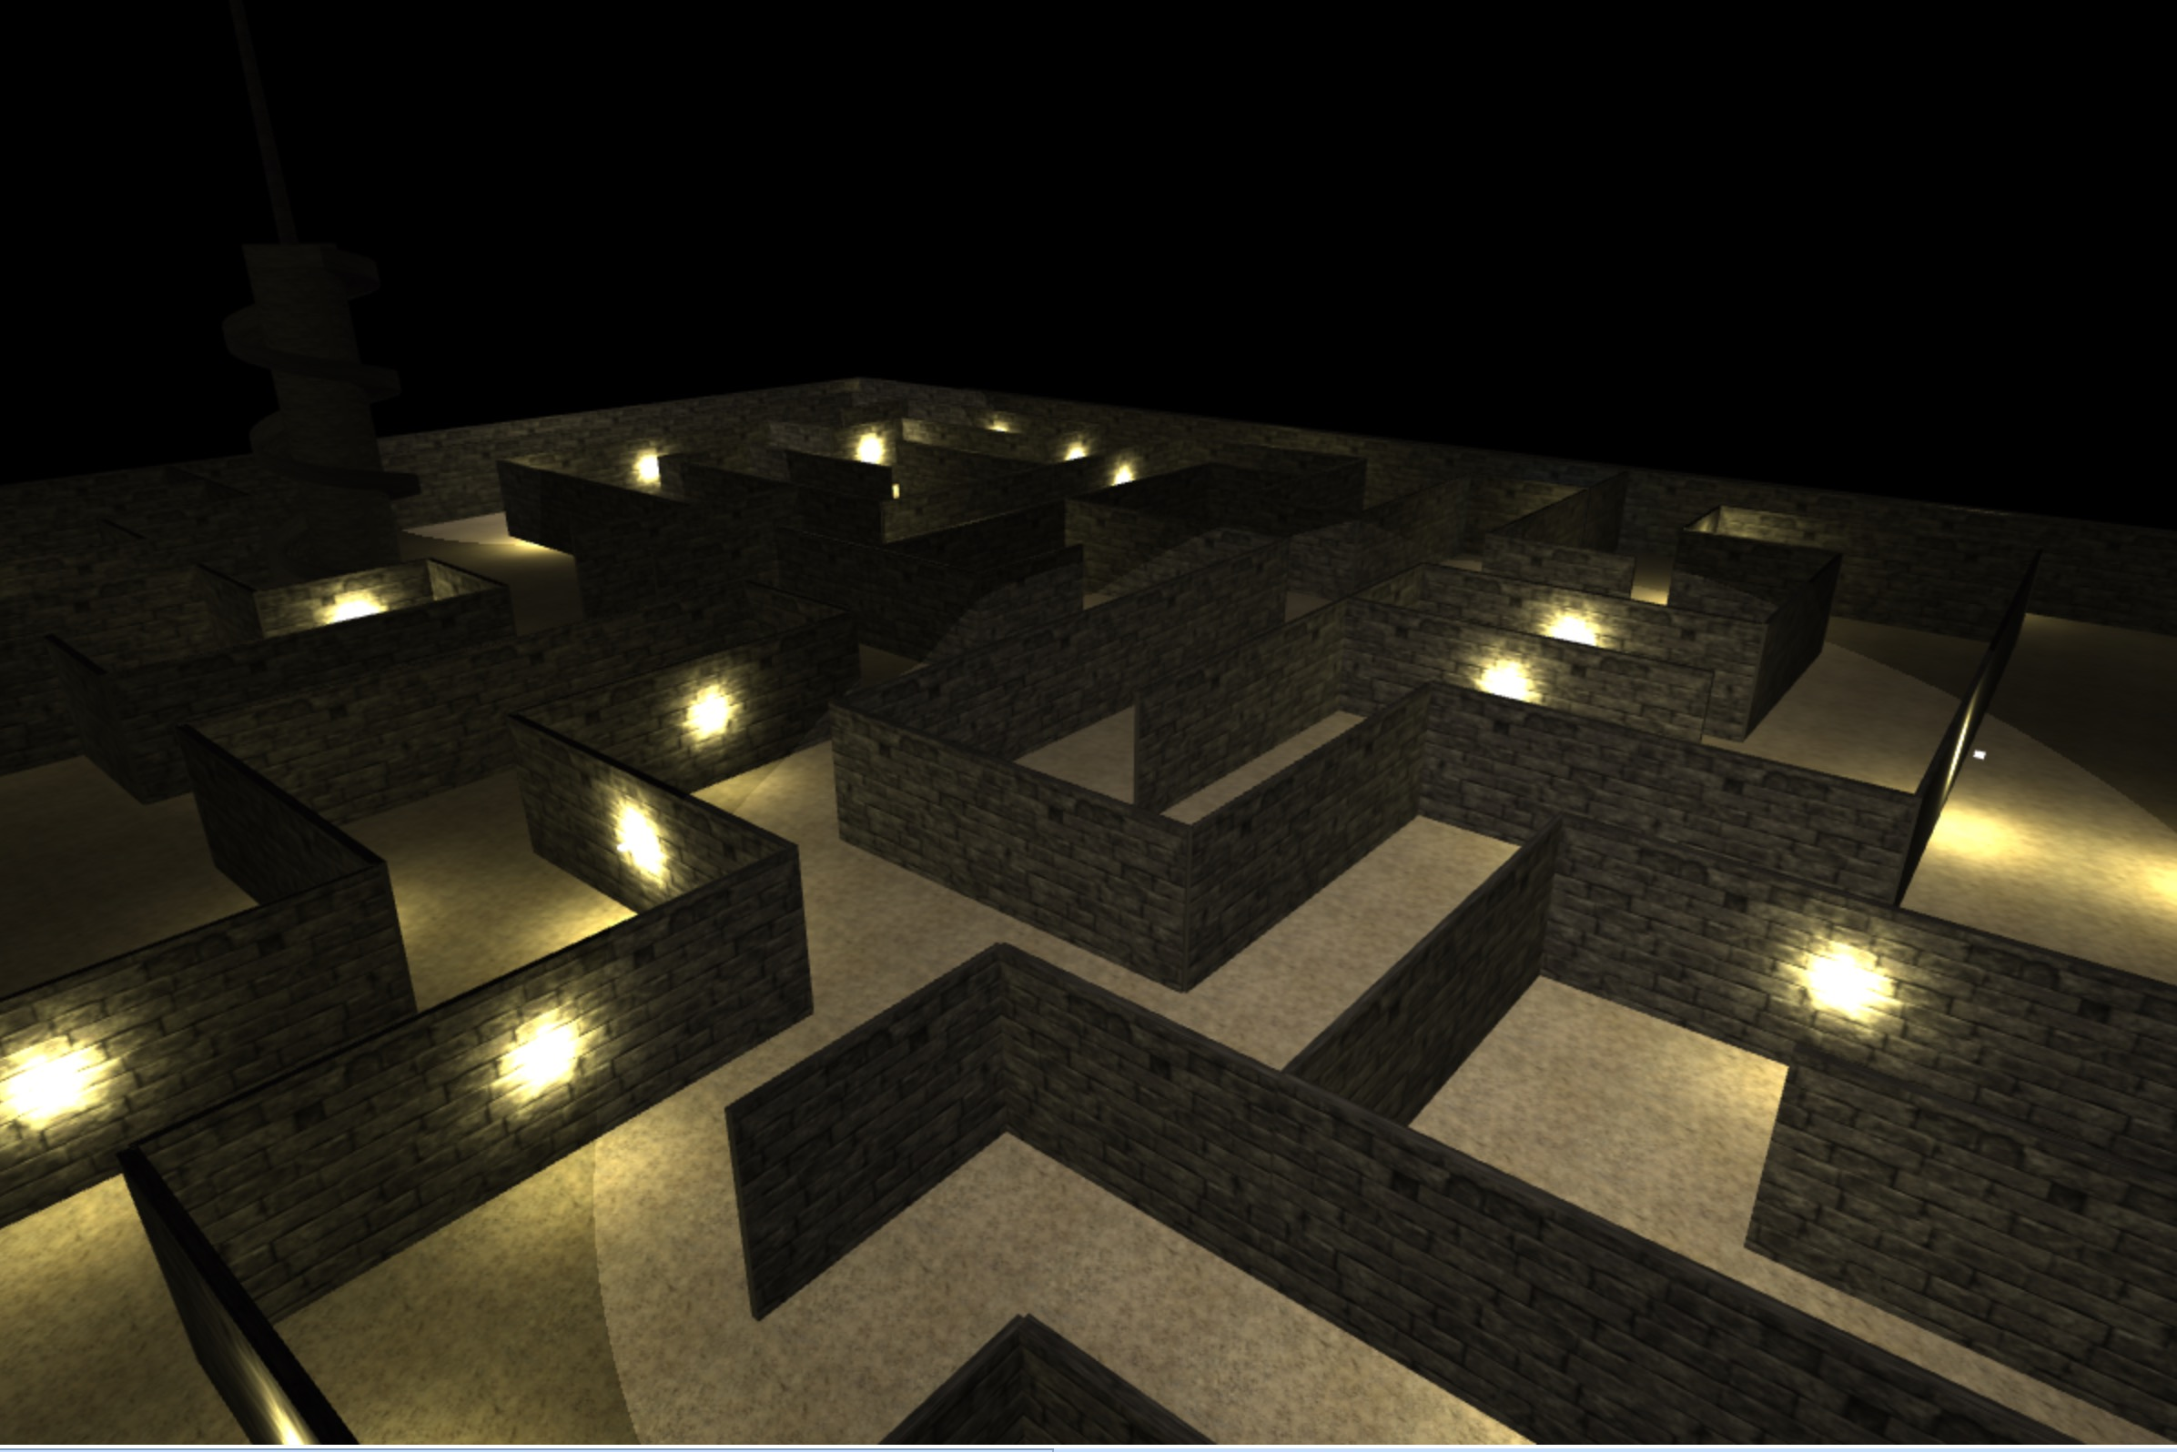

Figure 4. Looking down from a light house

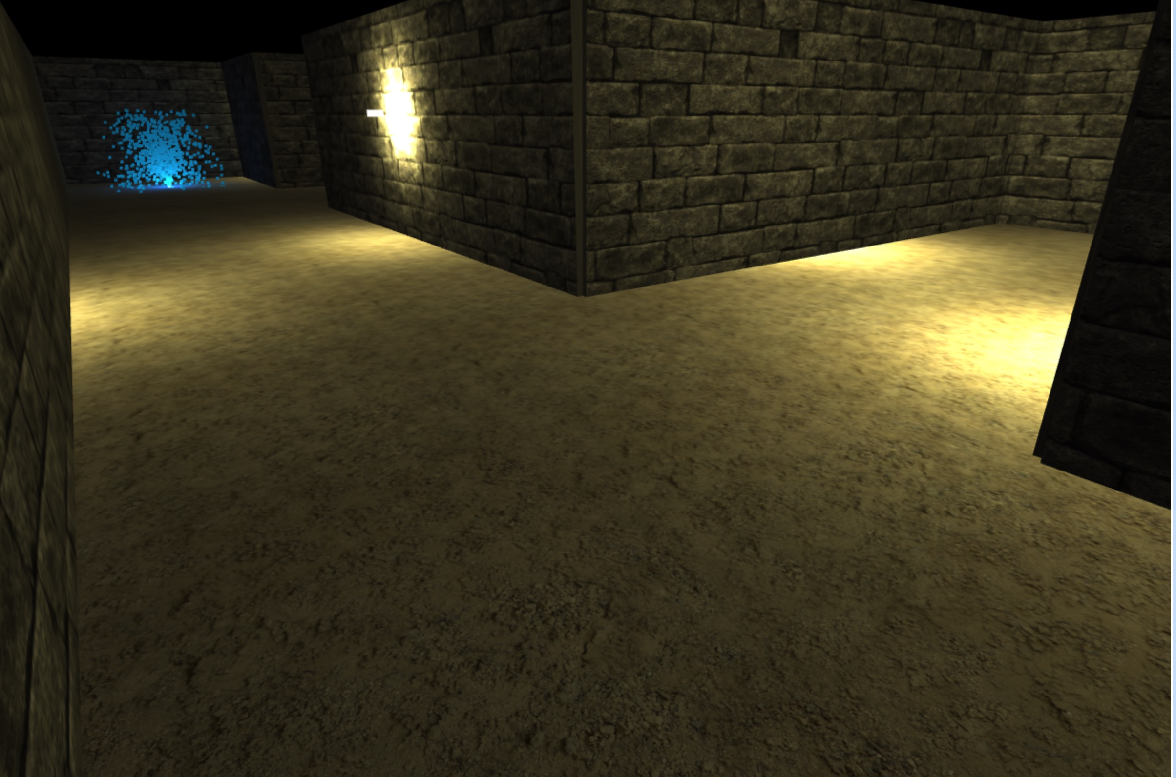  
Figure 5. Victory is around the corner

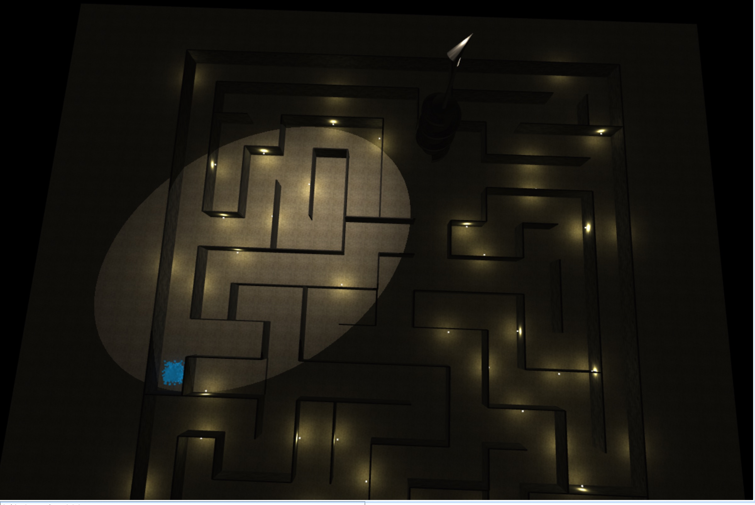

Figure 6. After victory, a whole picture of maze is shown

1. Challenge
2. Collision detection: The collision detection is necessary for a maze game. In this game we don’t check collision for all the triangle mesh. We only need to deal with player with walls and player with lighthouse. For player and wall collision detection we only need to care about X axis and Z axis and ignore y axis (the height direction). But for player and lighthouses collision we also need to check Y axis (because we need to “climb” the lighthouse).
3. Multiple light source with dynamic light:

There are many lights in this game such as wall lamp (point light source) and lighthouse spot light (spot light source). I also add some parameter that changing with time so that the scene will look fancier (luminance for point light and rotation for spot light).

1. Predefined moving object:

I also add some predefined moving object such as the Magic Fountain (a thousand particles moving under gravity, with random initial velocity), some walls (rise or fall when player triggers certain events).

1. Model design:

All the model uses in this project is drawing by myself (except the texture). Some models are complicated (the lighthouse, and the maze itself) and it takes some time to draw.

1. How to run
   1. Open the game: First unzip the file, then open a terminal under the maze_game directory and run python http server. Then in the browser open maze/maze.html. (e.g. <http://localhost:8000/maze/maze.html)>.
   2. Control the player: W/S: Moving forward/backward

A/D: Turn left/right

K/M: Looking up/down

* 1. System Environment: MacOs High Sierra 10.13.2, Safari 11.0.2